Date | 04 October 2026
Team ID | SWTID-2026-4732
Project Name | Implement Client Script & UI Policy (Incident)
Team Leader | Karuppa Sami Kasi Visvanathan S
Team member | Bala M
Team member | Saifur Rahuman Z
Team member | Karthik T
Maximum mark | 5

Validating the Solution: Testing Client Scripts and UI Policies

The final activity focuses on validating the complete Incident Management configuration created through UI Policies and Client Scripts. Testing is important to confirm that the configured rules behave correctly under different Incident conditions.

The idea was developed to test both successful and restricted scenarios, ensuring that mandatory enforcement, automatic updates, reverse conditions, list editing restrictions, and form-based updates work as intended.

The project user story is: As an Incident Management administrator, I want to test all configured UI Policies and Client Scripts so that Incident records follow the defined business rules and invalid or unauthorized updates are prevented.

The proposed testing process covers multiple scenarios. First, a High Impact Incident is created while leaving Assigned To empty. The system should prevent the Incident from being saved and display the appropriate error message. Next, Assigned To is populated and the Incident should save successfully.

A reverse condition test is then performed by changing Impact from High to Medium. The Assigned To field should no longer be mandatory and the Urgency field should become editable again.

The configuration is also tested from the Incident list by attempting to edit the State field directly. The onCellEdit Client Script should block the change and display an alert. Finally, State is changed through the Incident form to confirm that valid form-based updates are allowed.

Screenshot:

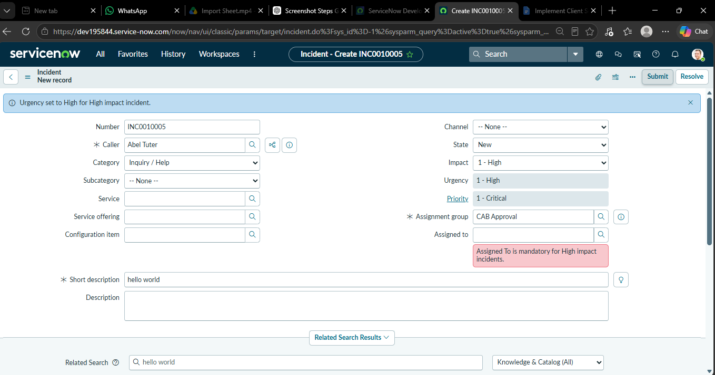

Process Testing Flowchart:

+-----------------------------------------------------------------+

| Final Phase: Complete Configuration Testing |

+-----------------------------------------------------------------+

|

V

+-----------------------------------------------------------------+

| 1. Mandatory Enforcement Test |

| Action: Save High Impact Incident with empty 'Assigned To' |

| Result: Save prevented, error message displayed |

+-----------------------------------------------------------------+

|

V

+-----------------------------------------------------------------+

| 2. Successful Save Test |

| Action: Populate 'Assigned To' and click Save |

| Result: Incident saved successfully |

+-----------------------------------------------------------------+

|

V

+-----------------------------------------------------------------+

| 3. Reverse Condition Test |

| Action: Change Impact from 'High' to 'Medium' |

| Result: Assigned To not mandatory, Urgency becomes editable |

+-----------------------------------------------------------------+

|

V

+-----------------------------------------------------------------+

| 4. List Edit Restriction Test |

| Action: Attempt to modify 'State' directly in List View |

| Result: Update blocked, alert message displayed |

+-----------------------------------------------------------------+

|

V

+-----------------------------------------------------------------+

| 5. Form-Based Update Test |

| Action: Modify 'State' field directly inside the Incident Form |

| Result: Valid update allowed, saved successfully |

+-----------------------------------------------------------------+

Validation Testing Details (Table Format)

Test Scenario | Action Performed | Expected Result
Mandatory Check | Create High Impact Incident, leave 'Assigned To' empty | Save blocked; error message displayed.
Valid Save Check | Fill 'Assigned To' field and click save | Incident saves successfully.
Reverse Condition | Change Impact from 'High' to 'Medium' | 'Assigned To' becomes optional; 'Urgency' editable.
List Edit Check | Double-click 'State' field from Incident List view | Change blocked; script alert triggered.
Form Edit Check | Open Incident form and change 'State' value | Valid update permitted; record saved.

Final Phase: User Acceptance Testing (UAT) & Quality Validation

Objective of Validation

The primary goal of this final phase is to perform end-to-end validation of the implemented UI Policies and Client Scripts. This process ensures that all dynamic form behaviors, mandatory field enforcements, and data integrity rules function exactly as defined in the business requirements without impacting standard system performance.

Test Execution Summary

To confirm system stability and rule enforcement, the configuration was evaluated against the following testing scenarios:

Negative Testing (Mandatory Field Enforcement): Attempted to save a High Impact Incident with an empty 'Assigned To' field. The system successfully blocked the submission and triggered the expected error message, validating the onSubmit Client Script.

Positive Testing (Standard Record Submission): Populated all required fields for a High Impact Incident. The system allowed the save action without errors, confirming that legitimate data entry is processed correctly.

Dynamic UI Validation (Reverse Condition Check): Downgraded the Incident Impact from 'High' to 'Medium'. The system instantly removed the mandatory constraint on 'Assigned To' and reverted the 'Urgency' field to an editable state, successfully validating the Reverse if false UI Policy configuration.

Data Security Check (List Edit Restriction): Attempted an unauthorized 'State' field update directly from the Incident List View. The onCellEdit script intercepted the action, blocked the update, and displayed the configured alert message.

Standard Operational Update (Form-Based Edit): Updated the 'State' field directly within the Incident form. The system permitted the change, confirming that authorized workflow actions remain unaffected by the list-edit restriction.

3. Final Project Conclusion

All testing scenarios have been executed and passed successfully. The implementation of the UI Policies and Client Scripts has significantly improved data consistency, eliminated incomplete high-impact incident submissions, and provided strict control over field modifications. The configuration meets all user story requirements and is ready for production deployment.

